**Lab - Week 4: Tasks and Tools**

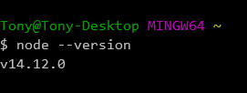

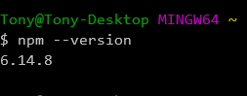

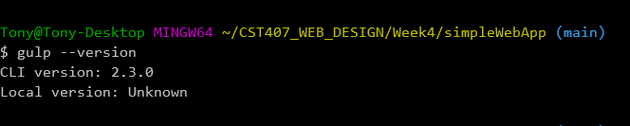

**Exercise 2 - Install build tools for your Web app (20 points)**

1. Add the gulp CLI.  From a terminal/command window in your lab folder run the following command. **Include a screenshot of the command and the command output.**

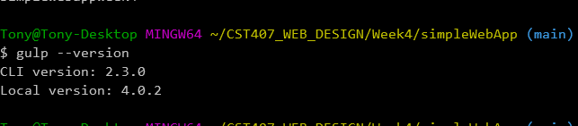

2. Install gulp and gulp plugins used for development build.  You'll find all of the development packages you'll need to install listed under **"devDependencies"**in my **package.json**file.  **Include a screenshot of each package install command and the command output**

